Latest Round-ups:
Season 2019/20
#16
Midweek Action: Tavistock ended a four-match winless run in the Premier Division on Tuesday evening, storming to a 3-0 victory away at Chipping Sodbury Town. The visitors led by one at the break thanks to an early strike from Josh Grant, with goals during the second half from Josh Robbins and Kian Burns completing the victory. Cribbs were also 3-0 winners, with a couple of late goals helping them see off the challenge of Wellington. The home side were afforded a one-goal advantage thanks to Jason Vincent, with the points only wrapped up during the final 15 minutes when both George Kellow and Ed Harrison found the back of the net. A strong second half performance from Bitton helped them claim a 4-2 win at home to Street. The visitors led twice during the first half thanks to goals from Leighton Thomas and Kyle Strange, with Bitton hitting back and drawing level on each occasion to make it 2-2 at the break. Josh Egan then scores his second goal of the evening to hand Bitton their first lead, before a well-taken effort from Karim Rendall secured the three points. Buckland Athletic held off a late challenge from Cadbury Heath to claim a 2-1 win at Homers Heath. Goals either side of the interval from Gavin Hammon and Richard Groves put Buckland on track for victory, with the Matt Huxley inspired Heath falling just short in their attempts at a fightback. A late equaliser helped Roman Glass St George secure a 1-1 draw away at Brislington to extend their unbeaten run to seven matches. The home side took a one-goal lead to the break thanks to Neikell Plummer’s penalty at the end of the first half, but Roman Glass are a confident side right now, and they grabbed a share of the points when George Box fired home six minutes from time to level the scores.
Two of Tuesday’s Somerset Premier Cup fixtures were decided on penalties during an entertaining night of knockout games. At West Clewes, Welton Rovers knocked Larkhall Athletic out for the third consecutive season following a sudden death shootout victory. Having trailed for much of the contest, Rovers struck in the dying moments when Alex Wych headed home a 95th minute corner to send the games to spot kicks. Rovers were perfect from 12 yards, converting all seven of their attempts to seal their spot in the third round. The other fixture requiring penalties saw Hengrove knock out Ashton & Backwell United, with the away side coming from two goals down to claim a 2-2 draw before prevailing 4-3 in the shootout. Cheddar produced a comeback of their own at home to Bishops Lydeard, with goals from Adam Jones and Adam Wright during the second half helping them to secure a 2-1 win. The other tie was a little more one-sided, with early goals from Craig Herrod and Tom Hill, plus a second half brace from Harry Foster giving Wells City a 4-1 victory over Bishop Sutton.
On Wednesday evening, an inspired performance from keeper Jake Viney helped Bridgwater Town secure their spot in the third round of the FA Vase. Hosting Saltash United, Viney made a number of fine saves during the 90 minutes, with the game ending goalless at the end of normal time. Bridgwater’s match-winner proved to be Steve Murray, with the former Street forward scoring twice in the space of three minutes during the first half of extra-time to give the Western League outfit a 2-0 victory. And in other cup action, goals from Alex Bisp and Steve Wingrove helped Almondsbury defeat Frampton United in the second round of the Gloucestershire Challenge Trophy, but it wasn’t such good news for Warminster who fell to a 3-2 defeat away at Downton in the Wiltshire Senior Cup.
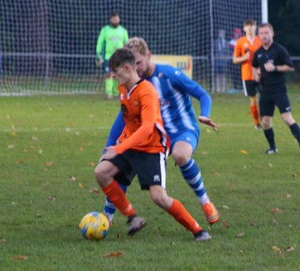
Premier Division: In the game of the day, Plymouth Parkway came out on top in a seven-goal thriller at home to Bitton, coming from behind on a couple of occasions before eventually grabbing a 4-3 victory. After top scorer Adam Carter had given the Devon-side a 22nd minute lead, Josh Egan struck twice to put Bitton ahead just prior to half-time. Parkway however were able to respond in first half stoppage time, with Shane Krac chipping the ball home to leave the game level at two apiece. The away side went back in front on the hour mark after Matt Groves found himself unmarked at the back post, with Parkway then levelling affairs once again when Carter completed his double. It was then left to Mikey Williams to complete the turnaround, with the forward’s 10th league goal of the campaign midway through the second half handing Parkway three valuable points. Bradford Town maintained their three point lead atop the division after holding off a late challenge from hosts Roman Glass St George during their 2-1 win. Lewis Powell gave Bradford a 10th minute lead in controversial circumstances, with the frontman originally flagged offside, but the referee waved play on before Powell rolled the ball home. Powell then doubled his tally in the 24th minute, and Bradford then held off a late charge from their hosts who struck a consolation goal towards the end of the game. A dominant second half showing from Exmouth Town led them to a 5-1 victory away at Cadbury Heath. Having taken a 17th minute lead through Aaron Denny, Exmouth found themselves level at the break following an equaliser at the end of the first half from Matt Binding. Tom Gardner restored Town’s advantage ten minutes into the second half, and from there they didn’t look back, with Jordan Harris, Ben Steer and Ace High completing the victory. Clevedon Town have now won four on the spin in all competitions after beating Wellington 3-1. Having broken the deadlock towards the end of the first half, Zach Drew then turned provider, laying on the assist for Jay Murray to make it 2-0 in Clevedon’s favour with ten minutes left on the clock. Lucas Vowles fired home an excellent third a couple of moments later, before Tom Stone bagged a late consolation for the hosts.
Action from Clevedon Town’s 3-1 victory away at Wellington.
Another side to triumph by three goals to one were fourth-placed Brislington, for whom Neikell Plummer struck in either half of their victory at home to Odd Down. Cribbs survived an early blitz from Keynsham before storming to a 5-2 victory at the Crown Fields. An own goal in the 10th minute doubled Keynsham’s early advantage after Tom Knighton had fired them ahead in the early stages. Cribbs then turned the game on its head, scoring four first half goals to build a comfortable lead at the break, before adding a fifth and final game in the 63rd minute to wrap up victory. Shepton Mallet’s return to form continued at home to Bridgwater Town, where a flicked finish 12 minutes from time by Conrad Peck handed them a well-earned 1-0 victory. Tavistock were also able to win on home territory, with goals in either half from Jordan Annear and Ben Cross leading them to a 2-0 victory over Bridport.
First Division: Cheddar came out on top following a drama-filled Friday night fixture on Friday evening, overturning a two-goal deficit to defeat Bishop Sutton 3-2. The away side have been struggling of late, having only won once since the end of August, but they made a terrific start at Bowdens Park, leading by two goals to nil after just half an hour. The Cheesemen were looking for a foothold into the game, and they were afforded that at the end of the opening half, when Ricky Bennett slotted home a penalty following a deliberate handball by the Bishop Sutton defender. The referee became a prominent figure in the game during the second half, and after dismissing a player from either side, the two managers were also given their marching orders as ill-discipline threatened to dictate the contest. Cheddar regained their composure fastest however, and after substitute Callum Ham had lobbed the keeper to level the scores, the visitors saw one of their number put in the sin-bin to hand the late advantage to their opponents. Bennett proved to be the hero for Cheddar, scoring directly from a corner in the closing stages to bring the curtain down on a memorable night under the floodlights in the Mendip's. On Saturday, Longwell Green Sports’ extended their winning run away at Welton Rovers, scoring a pair of early goals to help them to a 3-0 victory. After Kyle Box’s speculative effort put the visitors in front on the quarter-hour mark, Luke Bryan then stroked the ball home seven minutes later to give Longwell Green a strong foothold. The third and final goal also came before the break, with Jordan Greenwood tapping home to put them within one point of the top two in the league table. Leaders Calne Town came unstuck away at Warminster Town, with a 1-0 defeat ending their six-match unbeaten run. The pivotal moment in the game came five minutes before half-time, with Warminster’s Ian Jeffery slotting home a rebound after his penalty attempt had been kept out by Calne keeper Sam Thomson. Connor Williams scored with the final kick of the game to give Wincanton Town a dramatic 3-2 victory away at Portishead. After Toby Cole had given the visitors a 7th minute lead, Portishead hit back, and led at the interval thanks to a pair of quick-fire goals. Cole then struck again midway through the second half to draw the game level, setting up a tense finale, with Williams then striking in the fifth minute of stoppage time to give Wincanton all three points.
Sherborne Town leapfrogged Oldland Abbotonians after beating the Gloucestershire side 2-0 at Raleigh Grove. Alex Murphy proved to be the hero for the Zebra’s, breaking the deadlock at the end of the first half, before doubling his tally midway through the second to hand Sherborne their seventh league win of the campaign. Just ahead of Sherborne in the table are Lebeq United, and they were victorious again on Saturday afternoon, with first half goals from Jabari Ngozi and Elan Plummer leading them to a 2-0 win away at Bristol Telephones. Harry Greenbury struck twice to help Almondsbury come from two goals down to draw 2-2 away at Radstock. The Almonds made a disastrous start to the contest, finding themselves two goals down within 20 minutes, but fought back after the interval with Greenbury heading home a Greg Parr free kick in the 67th minute, before curling home the equaliser seven minutes from time. At the Lancer Scott Stadium, Bishops Lydeard climbed up to 13th spot thanks to a 3-1 win away at Ashton & Backwell United. Neither side managed to find the back of the net at the Athletic Ground, where Wells City and Hengrove Athletic battled out a goalless draw.
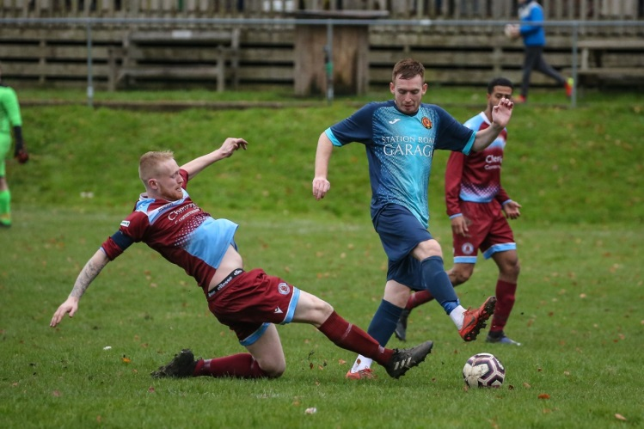
Cup Action: There was mixed fortunes for the two Western League sides in Wiltshire Cup action on Saturday afternoon, with Devizes unable to join Corsham in qualifying for the third round. A double from Leigh Rogers helped fire Corsham to a 3-0 victory away at Shrewton United, while Devizes fell to a 2-1 defeat away at Trowbridge Town. The image on the right is action from Corsham’s victory, courtesy of John Cuthbertson.

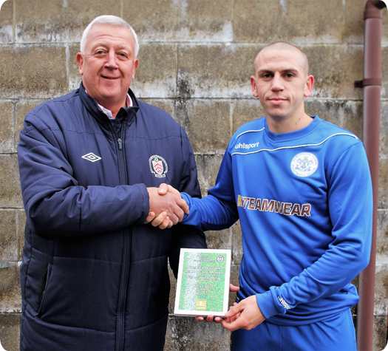
Awards Update

Team of the Month
Clevedon Town skipper Callum Kingdon is presented with the Premier Division Team of the Month award for September by League Director Geoff Endicot

Western League Statistical Leaders

PREMIER DIVISION LEADING GOAL SCORERS (League only):
Adam Carter (Plymouth Parkway) – 19
Josh Egan (Bitton) – 11
Lucas Vowles (Clevedon Town) – 10
Mikey Williams (Plymouth Parkway) – 10

PREMIER DIVISION TOP ATTENDANCES:
Bridport 0 Bridgwater Town 6, Sunday 6th October 2019 – 347
Wellington 0 Exmouth Town 2, Sunday 6th October 2019 - 315
Plymouth Parkway 1 Exmouth Town 0, Wednesday 21st August 2019 - 308

FIRST DIVISION LEADING GOAL SCORERS (League only):
James Rustell (Radstock Town) – 15
Harry Foster (Wells City) – 11
Stuart Windsor (Calne Town) – 11
Adam Wright (Cheddar) – 10
Danny Carter (Longwell Green Sports) - 10

FIRST DIVISION TOP ATTENDANCES:
Warminster Town 2 Bristol Telephones 3, Saturday 5th October - 369
Portishead Town 3 Longwell Green Sports 5, Saturday 5th October – 262
Devizes Town 0 Ashton & Backwell United 1, Saturday 5th October – 252

LEADING SCORERS IN ALL COMPETITIONS:
Jack Crago (Tavistock) - 23
James Rustell (Radstock Town) – 20
Adam Carter (Plymouth Parkway) – 20
Harry Foster (Wells City) – 16
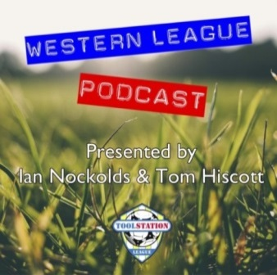
Jack Taylor (Bridgwater Town) - 15

*All goalscoring stats via
Be sure to check out the latest podcast, where Ian, Tom & guests recap all the latest news and results from around the Western League. To follow along all season, each broadcast will be available at the following link: http://www.toolstationleague.com/podcasts.php
Full-Time FA website

Latest Results
Tuesday 12th November 2019
Premier Division
Bitton 4-2 Street 59
Brislington 1-1 Roman Glass St George 40
Buckland Athletic 2-1 Cadbury Heath 75
Chipping Sodbury Town 0-3 Tavistock 58
Cribbs 3-0 Wellington 56
GFA Challenge Trophy – Second Round
Almondsbury 2-0 Frampton United
Somerset FA Premier Cup – Second Round
Ashton & Backwell United 2-2 (3-4 pens) Hengrove Athletic 64
Cheddar 2-1 Bishops Lydeard
Wells City 4-1 Bishop Sutton
Welton Rovers 1-1 (7-6 pens) Larkhall Athletic
Wiltshire FA Senior Cup – Second Round
Downton 3-2 Warminster Town
Wednesday 13th November 2019
FA Vase – Second Round
Bridgwater Town 0-0 (2-0 AET) Saltash United
Friday 15th November 2019
First Division
Cheddar 3-2 Bishop Sutton 98
Saturday 16th November 2019
Premier Division
Brislington 3-1 Odd Down 59
Buckland Athletic P-P Hallen
Cadbury Heath 1-5 Exmouth Town 48
Keynsham Town 2-5 Cribbs 141
Plymouth Parkway 4-3 Bitton 256
Roman Glass St George 1-2 Bradford Town
Shepton Mallet 1-0 Bridgwater Town 178
Tavistock 2-0 Bridport
Wellington 1-3 Clevedon Town 65
First Division
Ashton & Backwell United 1-3 Bishops Lydeard 81
Bristol Telephones 0-2 Lebeq United 43
Portishead Town 2-3 Wincanton Town 40
Radstock Town 2-2 Almondsbury 54
Sherborne Town 2-0 Oldland Abbotonians 67
Warminster Town 1-0 Calne Town 130
Wells City 0-0 Hengrove Athletic 45
Welton Rovers 0-3 Longwell Green Sports 75
Wiltshire FA Senior Cup – Second Round
Shrewton United 0-3 Corsham Town
Trowbridge Town 2-1 Devizes Town

Upcoming Fixtures
Monday 18th November 2019
Wiltshire FA Senior Cup – Second Round
Cricklade vs Calne Town 19:45KO
Tuesday 19th November 2019
GFA Challenge Trophy – First Round
Bitton vs Stonehouse 19:30KO
Hallen vs Sharpness 19:30KO
Somerset FA Premier Cup – Second Round
Keynsham Town vs Bridgwater Town 19:45KO
Les Phillips Cup – First Round
Brislington vs Bradford Town 19:30KO
Wednesday 20th November 2019
Premier Division
Wellington vs Plymouth Parkway 19:45KO
Westbury United vs Street 19:30KO
First Division
Hengrove Athletic vs Sherborne Town 19:30KO
GFA Challenge Trophy – First Round
Cadbury Heath vs Bristol Telephones 19:30KO
Roman Glass St George vs Bourton Rovers 19:30KO
Saturday 23rd November 2019 (KICK OFF AT 3.00PM UNLESS NOTED)
Premier Division
Bitton vs Wellington
Bridport vs Chipping Sodbury Town
Cadbury Heath vs Clevedon Town
Cribbs vs Bridgwater Town
Hallen vs Westbury United
Keynsham Town vs Buckland Athletic
Odd Down vs Exmouth Town
Roman Glass St George vs Brislington
Shepton Mallet vs Tavistock
Street vs Bradford Town
First Division
Almondsbury vs Warminster Town
Bishop Sutton vs Bristol Telephones
Bishops Lydeard vs Lebeq United
Corsham Town vs Calne Town
Hengrove Athletic vs Wincanton Town
Longwell Green Sports vs Devizes Town
Oldland Abbotonians vs Radstock Town
Portishead Town vs Cheddar
Sherborne Town vs Ashton & Backwell United
Wells City vs Welton Rovers

League Tables
Premier Division
 |  | P | W | D | L | F | A | GD | PTS
1 | Bradford Town | 13 | 11 | 1 | 1 | 41 | 14 | 27 | 34
2 | Plymouth Parkway | 12 | 10 | 1 | 1 | 52 | 13 | 39 | 31
3 | Clevedon Town | 14 | 8 | 1 | 5 | 32 | 31 | 1 | 25
4 | Brislington | 17 | 8 | 1 | 8 | 27 | 40 | -13 | 25
5 | Exmouth Town | 10 | 8 | 0 | 2 | 27 | 6 | 21 | 24
6 | Bridgwater Town | 13 | 7 | 3 | 3 | 39 | 19 | 20 | 24
7 | Westbury United | 13 | 7 | 2 | 4 | 31 | 20 | 11 | 23
8 | Hallen | 13 | 7 | 2 | 4 | 27 | 24 | 3 | 23
9 | Bitton | 12 | 7 | 0 | 5 | 36 | 22 | 14 | 21
10 | Shepton Mallet | 11 | 6 | 2 | 3 | 22 | 16 | 6 | 20
11 | Cribbs | 15 | 6 | 2 | 7 | 24 | 32 | -8 | 20
12 | Buckland Athletic | 12 | 6 | 1 | 5 | 22 | 22 | 0 | 19
13 | Street | 13 | 6 | 0 | 7 | 32 | 31 | 1 | 18
14 | Tavistock | 10 | 5 | 2 | 3 | 24 | 16 | 8 | 17
15 | Keynsham Town | 13 | 4 | 2 | 7 | 28 | 37 | -9 | 14
16 | Cadbury Heath | 15 | 3 | 5 | 7 | 20 | 33 | -13 | 14
17 | Roman Glass St George | 11 | 4 | 1 | 6 | 27 | 15 | 12 | 13
18 | Odd Down | 14 | 3 | 1 | 10 | 14 | 35 | -21 | 10
19 | Wellington | 15 | 3 | 1 | 11 | 17 | 39 | -22 | 10
20 | Bridport | 17 | 3 | 1 | 13 | 21 | 61 | -40 | 10
21 | Chipping Sodbury Town | 15 | 2 | 1 | 12 | 15 | 52 | -37 | 7

First Division
 |  | P | W | D | L | F | A | GD | PTS
1 | Calne Town | 13 | 8 | 2 | 3 | 20 | 8 | 12 | 26
2 | Wincanton Town | 12 | 8 | 2 | 2 | 28 | 19 | 9 | 26
3 | Longwell Green Sports | 12 | 8 | 1 | 3 | 29 | 19 | 10 | 25
4 | Radstock Town | 12 | 7 | 1 | 4 | 30 | 22 | 8 | 22
5 | Ashton & Backwell United | 13 | 6 | 4 | 3 | 20 | 20 | 0 | 22
6 | Wells City | 12 | 6 | 3 | 3 | 29 | 18 | 11 | 21
7 | Lebeq United | 14 | 7 | 0 | 7 | 31 | 27 | 4 | 21
8 | Sherborne Town | 11 | 7 | 0 | 4 | 22 | 19 | 3 | 21
9 | Cheddar | 12 | 6 | 2 | 4 | 24 | 19 | 5 | 20
10 | Oldland Abbotonians | 13 | 5 | 4 | 4 | 14 | 18 | -4 | 19
11 | Corsham Town | 14 | 6 | 1 | 7 | 26 | 38 | -12 | 19
12 | Almondsbury | 12 | 5 | 2 | 5 | 20 | 21 | -1 | 17
13 | Bishops Lydeard | 12 | 5 | 1 | 6 | 24 | 22 | 2 | 16
14 | Warminster Town | 12 | 5 | 0 | 7 | 24 | 18 | 6 | 15
15 | Welton Rovers | 13 | 4 | 2 | 7 | 16 | 26 | -10 | 14
16 | Portishead Town | 10 | 4 | 1 | 5 | 26 | 23 | 3 | 13
17 | Devizes Town | 10 | 2 | 4 | 4 | 20 | 20 | 0 | 10
18 | Hengrove Athletic | 12 | 2 | 4 | 6 | 7 | 28 | -21 | 10
19 | Bishop Sutton | 11 | 2 | 1 | 8 | 15 | 22 | -7 | 7
20 | Bristol Telephones | 14 | 1 | 1 | 12 | 17 | 35 | -18 | 4

